* Total sales per product.

db.sales.aggregate([{$group:{_id: ”$product”,totalSales:{$sum:{multiply:[“price”,”quantity ”]}}}}])

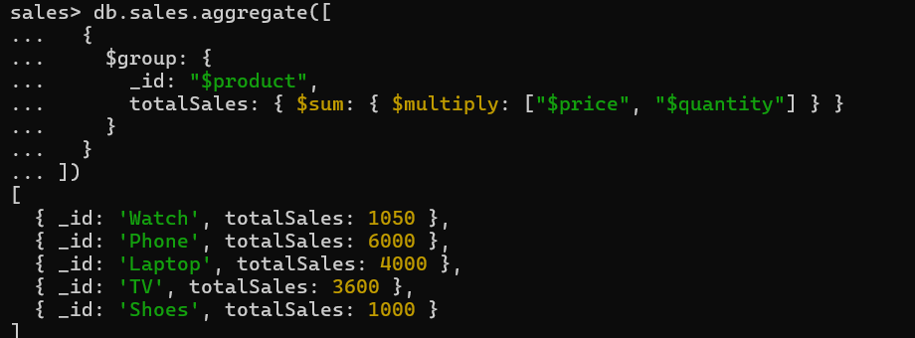

* Total revenue per product

--- this do sum of all products

db.sales.aggregate([{$group:{_id:"product",TotalSales:{$sum:{$multiply:["$price","$quantity"]}}}}])

[ { _id: 'product', TotalSales: 15650 } ]

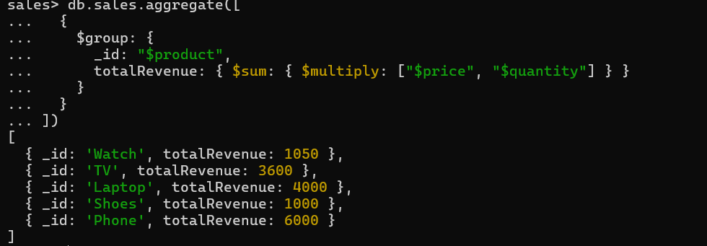

* Total revenue per category.

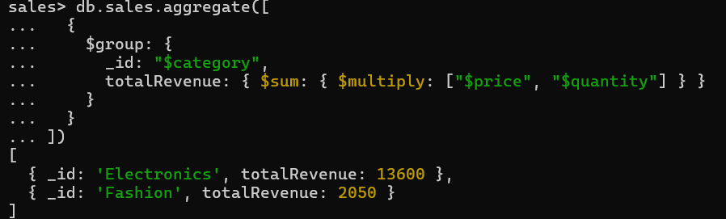

* Count of products per category.

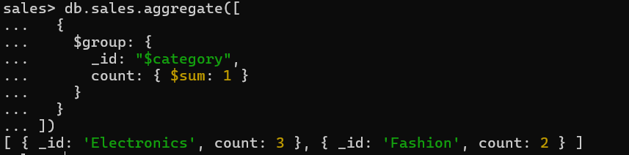

* Store-wise total sales.

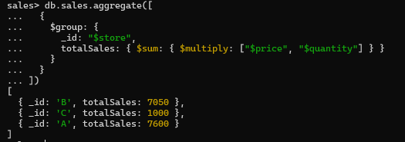

* Average price of products per category.

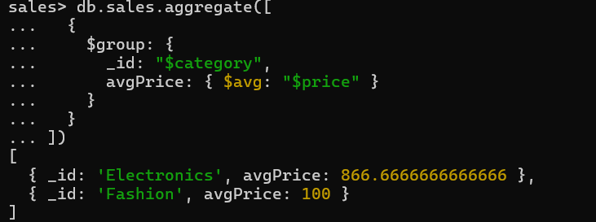

* Top-selling product.

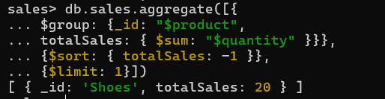

* Total sales for Electronics category.

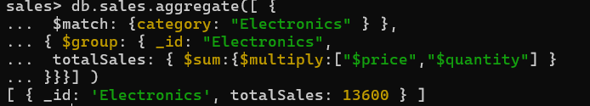

* Sales trend over time (day-wise total sales).



* Highest revenue-generating product.

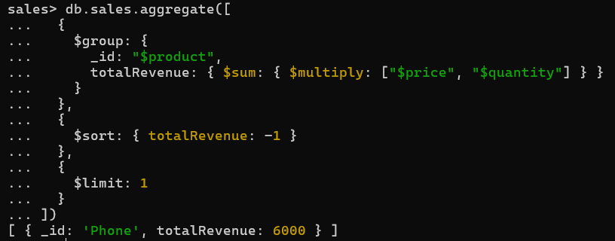

* Average revenue per sale.

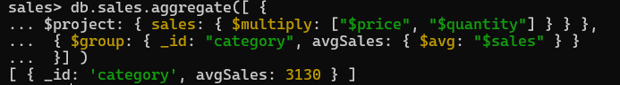

* Sales performance per store.



* Products sold more than 5 times.

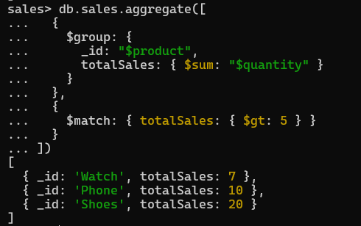

* Least sold product.

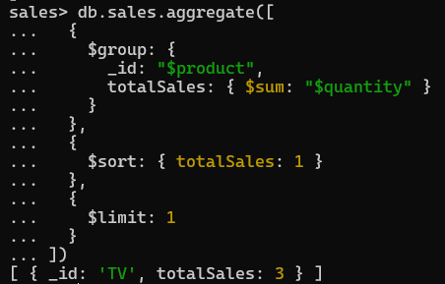

* Monthly sales summary.

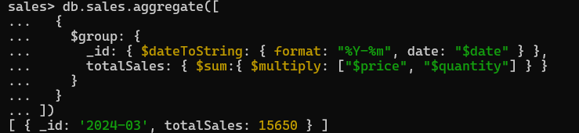

* Number of unique products sold.

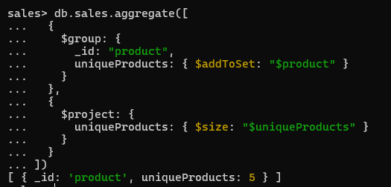

* Maximum and minimum priced product

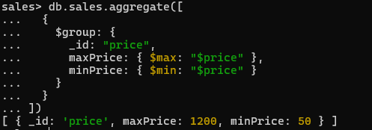

* Total revenue per product in descending order.

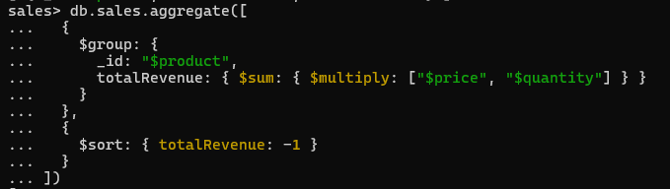

* Revenue generated per store per category.

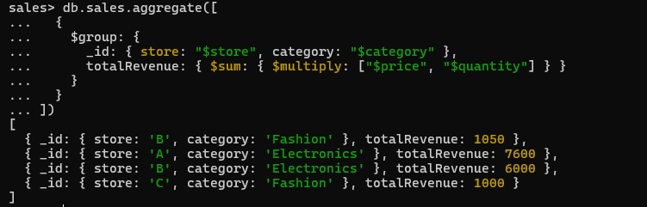

* Products contributing more than 50% revenue.

